Yagi Antenna Build Summary 12/1/15

# Components Required for cheap yagi build Armando A. Gonzalez-Feuchter

**PL-259 UHF-Male to SMA-Female Coaxial Adapter RFA-8183** Cost: 4.59 plus shipping

<http://testparts-store.com/pl-259-uhf-male-to-sma-female-coaxial-adapter-rfa-8183/>

**PL-259 Plug** Cost: 1.65 plus shipping

<http://www.allelectronics.com/make-a-store/item/pl-259/pl-259-plug/1.html?gclid=CJXizKf5mMkCFQUHaQodsVoCNQ>

**Low Loss Flexible LMR-195-FR Fire Rated Coax Cable Double Shielded** Cost 0.89 per feet + shipping

(I don’t see us requiring more than 3 feet since it would be a short connection)

<http://www.pasternack.com/50-ohm-flexible-lmr-195-fr-frpe-jacket-aluminum-tape-over-tinned-copper-braid-outer-conductor-double-shielded-black-lmr-195-fr-p.aspx?gclid=CPzbk6S1lskCFQ6OaQod8ioG7A>

Here is a link to a good summary of the science behind the driven element (dipole) that you asked about. Also it has some helpful construction tips concerning the driven element (look under a well fed yagi section). <http://www.hamuniverse.com/yagibasics.html>

Also here is a link to some of the reasoning as to why certain antennas are copper based and other aluminium based. It basically boils down to conductivity and weight to strength ratio. <http://www.eham.net/ehamforum/smf/index.php?topic=63152.0;wap2>

Here are the basic dimensions of the Yagi antenna with a ¼’’ aluminum rod build both for the dipole and the elements (even though you could make the dipole copper for better conductivity). Also it is insulated from the boom meaning you could use a wooden pole/ beam etc as long as the dimensions and spacing are accurate. Also I selected a generic 50 ohm coax cable from the program library but should work the same for the 50 ohm coax cable we are looking at.

**1/4 inch Dia. 6061-T6 Aluminum Round** Cost 4.60 per 4 feet + shipping

(Required estimate is around 1136mm of aluminium rod or 4 feet to be on the safe side)

<https://www.metalsdepot.com/catalog_cart_view.php?msg>=

**Total Cost of Home-Made Yagi Antenna $13.51 + shipping**

**(Cost does not reflect various bits and ends like screws, glue, etc. or the cost of a wooden beam)**

**Comparative After Market Yagi Antenna** (6 element) **$104.54 + shipping**

**(most aftermarkets are 6 – 7 element hence the price spike)**

<http://www.neobits.com/laird_technologies_y8966_896_970_mhz_9db_6_element_p3225812.html?atc=gbp&gclid=CKCq46ukvMkCFYcBaQodNj4MTQ>

VK5DJ's YAGI CALCULATOR

Yagi design frequency =900.00 MHz

Wavelength =333 mm

Parasitic elements fastened to a non-metallic or separated from boom

Folded dipole fully insulated from boom

Director/reflector diam =6.41 mm or ¼ inch

Radiator diam =6.41 mm

REFLECTOR

160.5 mm long at boom position = 30 mm (IT = 67.5 mm)

RADIATOR

Single dipole 152.8 mm tip to tip, spaced 67 mm from reflector at boom posn 97 mm (IT = 64.0 mm)

Folded dipole 155.8 mm tip to tip, spaced 67 mm from reflector at boom posn 97 mm (IT = 65.5 mm)

DIRECTORS

Dir Length Spaced Boom position IT Gain Gain

(no.) (mm) (mm) (mm) (mm) (dBd) (dBi)

1 136.5 25.0 121.6 56.0 4.8 6.9

2 134.5 60.0 181.6 55.0 6.5 8.6

3 132.7 71.6 253.2 54.0 7.8 9.9

4 130.9 83.3 336.5 53.0 8.9 11.0

5 129.3 93.3 429.7 52.0 9.8 11.9

COMMENTS

The abbreviation "IT" means "Insert To", it is the construction distance from the element tip to the edge of the boom for through boom mounting

Spacings measured centre to centre from previous element

Tolerance for element lengths is +/- 1 mm

Boom position is the mounting point for each element as measured from the rear of the boom and includes the 30 mm overhang.The total boom length is 460 mm including two overhangs of 30 mm

The beam's estimated 3dB beamwidth is 52 deg

A half wave 4:1 balun uses 0.66 velocity factor RG-55A (PE) and is 110 mm long plus leads

FOLDED DIPOLE CONSTRUCTION

Measurements are taken from the inside of bends

Folded dipole length measured tip to tip = 156mm

Total rod length =342mm

Centre of rod=171mm

Distance BC=CD=60mm

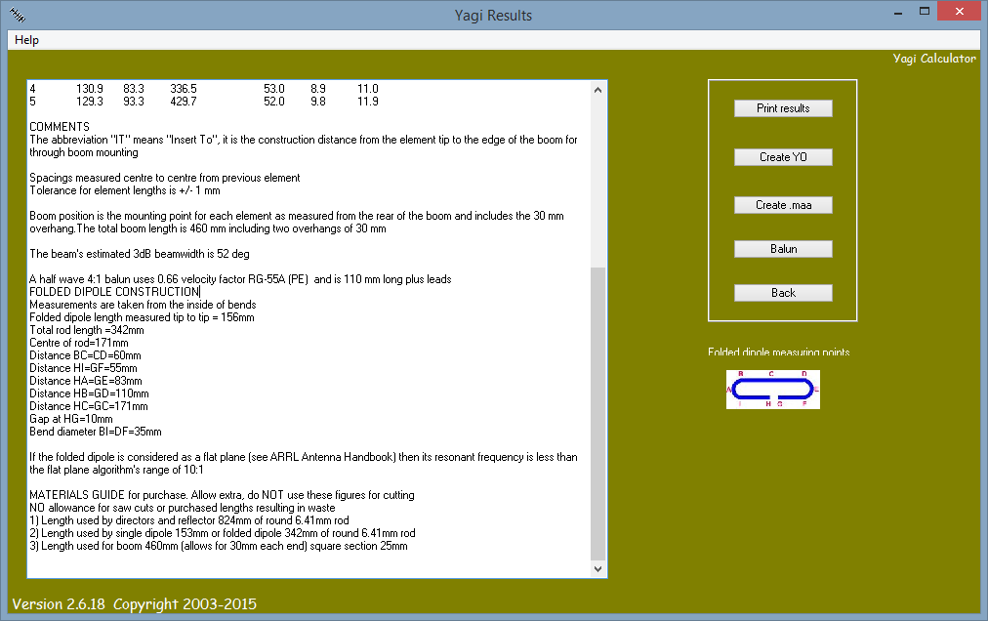Distance HI=GF=55mm

Distance HA=GE=83mm

Distance HB=GD=110mm

Distance HC=GC=171mm

Gap at HG=10mm

Bend diameter BI=DF=35mm

If the folded dipole is considered as a flat plane (see ARRL Antenna Handbook) then its resonant frequency is less than the flat plane algorithm's range of 10:1

MATERIALS GUIDE for purchase. Allow extra, do NOT use these figures for cutting

NO allowance for saw cuts or purchased lengths resulting in waste

1) Length used by directors and reflector 824mm of round 6.41mm rod

2) Length used by single dipole 153mm or folded dipole 342mm of round 6.41mm rod

3) Length used for boom 460mm (allows for 30mm each end) square section 25mm